SETUP VERIFY CARD TRANSACTION TYPE

1. Create new transaction types

* Navigate ROOT\OpenWay\Full\Configuration Setup\Transaction Types\Transactions - All
* Click “Insert new record”
* Input values
  + Service Class: Transaction
  + Source: Account
  + Target: Card
  + Name: Verify Card
  + Dr~\Cr: Debit
  + Chain Type: Original
  + Is Authorized: Never
  + Is Required: Yes
  + Category: Individual
  + RBS Code: VER
  + RBS Rev Code: ver
* Click “Save form changes”
* Click “Action” > “Fill”
  + Click “SubTypes”

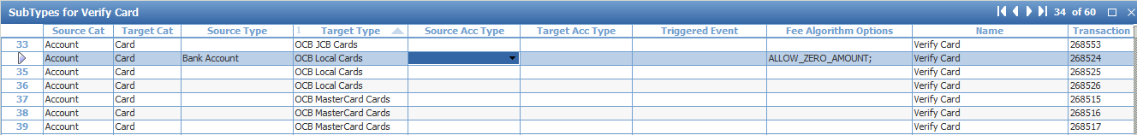

* + Click “Msg Types”



1. Setup Service Pack

* Navigate ROOT\OpenWay\Full\Configuration Setup\Products\Service Packs
* Select “001-Add LC Debit Base”, “001-Add LC Credit Base”, “001-Add LC Prepaid Base” & Click “Target” 🡪 Open “Target for …” form
* Click “Insert new record”
* Input values
  + Source Type: Bank Account
  + Transaction Type: Verify Card
  + Rate Type: Middle
  + Account Type: CH Current/Credits
* Click “Save form changes”
* Approve with current banking date
* Select “001-Add LC Debit Ecommerce Prevention”, “001-Add LC Credit Ecommerce Prevention”, “001-Add LC Prepaid Ecommerce Prevention” & Click “Target” 🡪 Open “Target for …” form
* Click “Insert new record”
* Input values
  + Source Type: Bank Account
  + Transaction Type: Verify Card
  + Rate Type: Middle
  + Account Type: CH Current/Credits
* Click “Save form changes”
* Click “Full Info” 🡪 Open “Full Info for …” form
  + Update values
    - Service Allowed: Never
  + Click “Save form changes”
  + Close form
* Approve with current banking date
* Approve related service pack